Let’s Talk About Adding and Subtracting!
Sample Social Media Posts

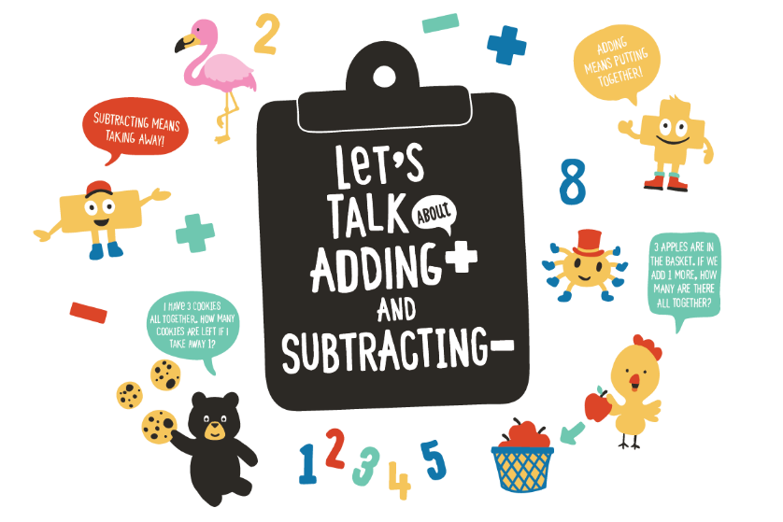
Facebook
Helping your child build his early math skills can be simple and fun! As you walk outside, count the number of steps you take. Count to ten, and then start over again! For other fun ideas on how to easily bring math learning to everyday activities, check out this tip sheet from @2SmallToFail: https://bit.ly/3o8Nn5V

Addition and subtraction are important building blocks of math, and by talking with your baby about these concepts you’re preparing her for kindergarten and beyond. During diaper time, wiggle and count your baby’s fingers and toes. “1..2..3..4..5! You have five toes on your foot!” Learn about other fun ways you can bring math into diaper time with this resource from @2SmallToFail: https://bit.ly/31nROA5

Twitter
Turn everyday moments into math moments! As you pull out letters from the mailbox, count them up with your child. “How many letters do we have? 1..2..3!” Find more ideas on how to talk, read, and sing with your child about addition and subtraction here: https://bit.ly/2IHY2Et

Turn cleanup time into counting time! Encourage your child to count his toys as he puts them away. “How many toys have you put away? How many toys are left on the floor?” #TalkingisTeaching

As you feed your baby, pause between each bite and ask, “One more?” This will help your little one begin to understand early math concepts like addition and subtraction. Find more ideas on everyday fun with math here: https://bit.ly/35hxiCi

Instagram
The world is full of opportunities to practice addition and subtraction! As you go for a walk with your little one, ask your child to count the steps between two stores. Then, count the steps between two streetlights. Which took more steps? Which distance is farther? For more ways to play with math outside, click here: https://bit.ly/3khUvL2

Turn snack time into math time! Give your child a plate of grapes and ask, “There are ten grapes on your plate. If you eat three, how many grapes will you have left? How do you know?” #TalkingisTeaching

