Let’s Talk About Music!
Sample Social Media Posts
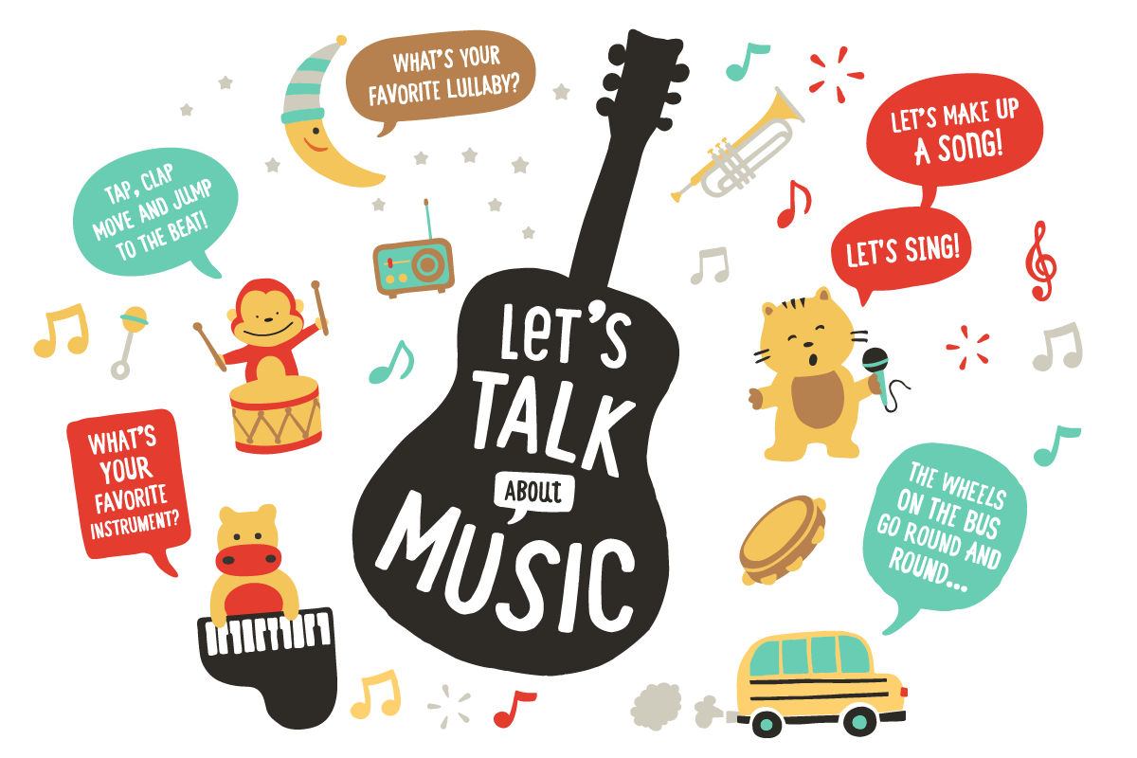

Facebook
Did you know that music and singing can help boost your baby’s language development and help prepare him for success in school? When you sing songs together, your baby learns new words, sound patterns, and more! Learn more ways to build your baby’s brain with music here: https://bit.ly/3oJSSYg

With your little one, make your own musical instrument! Use tape to shut one end of a paper towel tube. Fill it with a pinch of rice or beans and tape the other end. Decorate it with pictures or stickers, and then shake, twirl, and dance! Find more fun musical activities to do at home here: https://bit.ly/379HgrF

Get your wiggles out and have a family dance party! Turn on your favorite songs and have fun singing and dancing together. Stop the music every once in a while to play “Freeze Dance!”

Twitter
As you tuck your little one into bed, sing a lullaby to help her fall asleep. Come up with your own lullaby to start an extra special nighttime routine! Learn how to create your own lullaby here: https://bit.ly/36J6A6e

Sing, clap, and dance along to the music with these fun playlists! Turn everyday moments, like bath time or diaper time, into a fun musical activity. Listen here: https://bit.ly/2JOuXZ8

Singing is a wonderful way to bond with your baby, and it also helps him learn new words! Sing favorite family songs together while swaying, bouncing, and clapping with your little one. #TalkingIsTeaching

Instagram
With your child, talk about your favorite instruments and songs together! “I like the drums because they make a fun, loud noise. What’s your favorite instrument?” #TalkingIsTeaching

There are so many songs from all across the world. Have fun listening to and learning children’s songs in different languages! #TalkingIsTeaching

