Let’s Talk About the Holidays!
Sample Social Media Posts

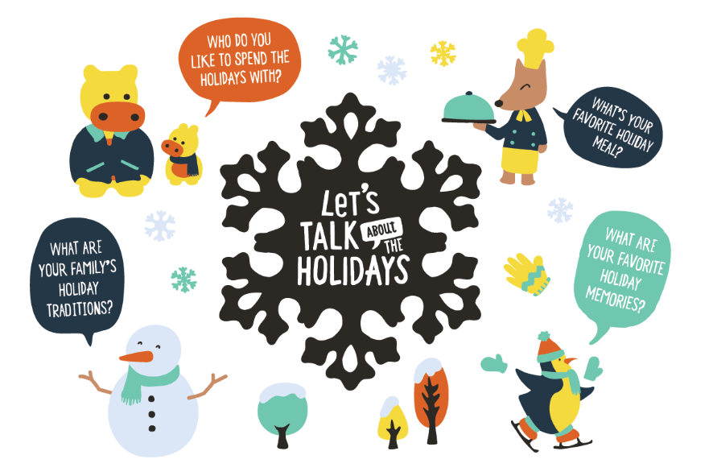

Facebook
- The winter season is filled with a variety of holidays and celebrations! With your little one, talk about the different holidays that your friends, family, and neighbors celebrate. “We celebrate Las Posadas by singing carols. What holidays do your friends celebrate?” #TalkingisTeaching

- Have fun with seasonal indoor arts and crafts with your child! Mix flour, water, salt, oil, and food coloring to make your own playdough. Ask your child, “How many shapes can you make with the playdough? What happens when we mix two playdough colors together?” Find more festive activities from @2smalltofail here: https://bit.ly/32B29JF

- This holiday season, share your family traditions with your child! Sing a lullaby that your mother or father sang to you or tell your child about stories from your own childhood. You can also start your own traditions with your child: a special weekend breakfast or a weekly game night are fun ways to bond with your child. #TalkingisTeaching

Twitter
- The holidays can be a stressful time of year. Remember that you don’t have to create the “perfect” holiday season for your child. For your little one, it’s special just to be able to spend quality time together.

- The holidays may look different this year due to the COVID-19 pandemic, and your child may feel upset with the changes. Reassure your child of what will stay the same, and let your child think about new fun activities to do as well. #TalkingisTeaching

- To help your baby fall asleep during winter nights, create and sing your own lullaby. Your baby loves to hear your voice, and singing supports your baby’s brain and language development. Learn how to create your own lullaby from @2smalltofail here: https://bit.ly/3nkx3Os

Instagram
- With your child, talk about what you love most about the holidays. “I love spending time with you and decorating our apartment! What do you like most about the holidays?” #TalkingisTeaching

- Bring some creativity into the holiday season! If you’re planning on sending gifts to loved ones, ask your little one to help create unique wrapping paper. Take a toy car, coat the wheels with white paint, and have your child roll it over kraft paper. Find more creative and fun activities from @2smalltofail here: https://bit.ly/2UnfQr2

