Let’s Talk About Letters!
Sample Social Media Posts
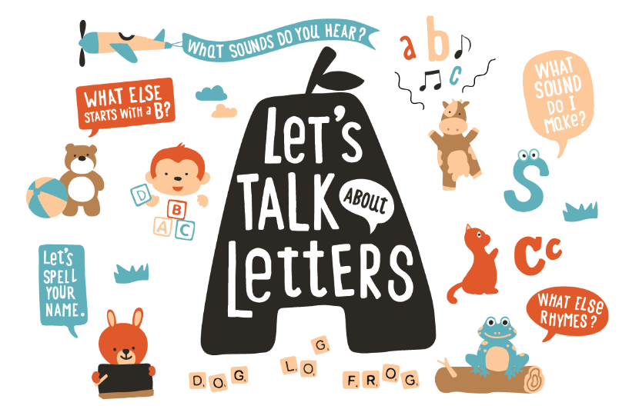
Facebook
When children know the letters of the alphabet, it will help them learn how to read and prepare them for kindergarten! There are many fun ways to talk, read, and sing about letters with your little one. Try a Letters Scavenger Hunt! Write a letter on a piece of paper, and with your child, look for that letter throughout your home! “Here is the letter ‘S’! Where can we find the letter ‘S’ in the kitchen?” #TalkingIsTeaching

As your little one learns how to write, you can brighten up someone’s day by writing a letter together! For an activity that is sure to create smiles while also helping your child practice the letters of the alphabet, join Letters from Little Ones! You and your child can write a letter to an older adult living in New York City who may be alone due to COVID-19. Sign up here: https://bit.ly/3siPZzo

For a fun arts and crafts activity, take a blank sheet of paper and, with your child, spell out your little one’s name! As you write and decorate the letters, talk about each letter in the name. “M...A...R...I...A! This letter is M, which makes a ‘Mmm’ sound! What other words begin with M?” Have fun writing the names of family members and friends and talking about each letter! #TalkingIsTeaching

Twitter
For a fun way to discover the letters of the alphabet with your little one, sing and dance along to the alphabet song! Want a new melody and beat to sing the ABCs with? Watch Sesame Street’s Alphabet Songs here: https://bit.ly/3dBG9Vt

You can find letters all throughout your home and community! As you go about your day with your little one, point out the letters you see and say the sounds of each letter. “Look at that stop sign! It starts with the letter ‘S’. S sounds like ‘Sss’!”#TalkingIsTeaching

When children learn more than one language, it helps build their growing brains! Show your little one letters and the sounds they make in different languages. To find recommendations on bilingual books about letters in English and Spanish, click here: https://bit.ly/3uMvqgP

Instagram
When you help your child recognize letters and their sounds, you help him learn how to read! On a sheet of paper, write the names of your family members and friends. Show your little on the names, and ask, “Who has an ‘A’ in their name? Yes, there’s an ‘A’ in Sam! Can you think of other words that have the letter ‘A’ in them?” #TalkingIsTeaching

As you tuck your little on into bed, read a bedtime story together! As you read, you can follow along the words with a finger. For older children, ask them if they recognize any of the letters in the story! Click here for a free children’s book that you can read with your child: https://bit.ly/3bsjOa0

