Let’s Talk About Patterns!
Sample Social Media Posts
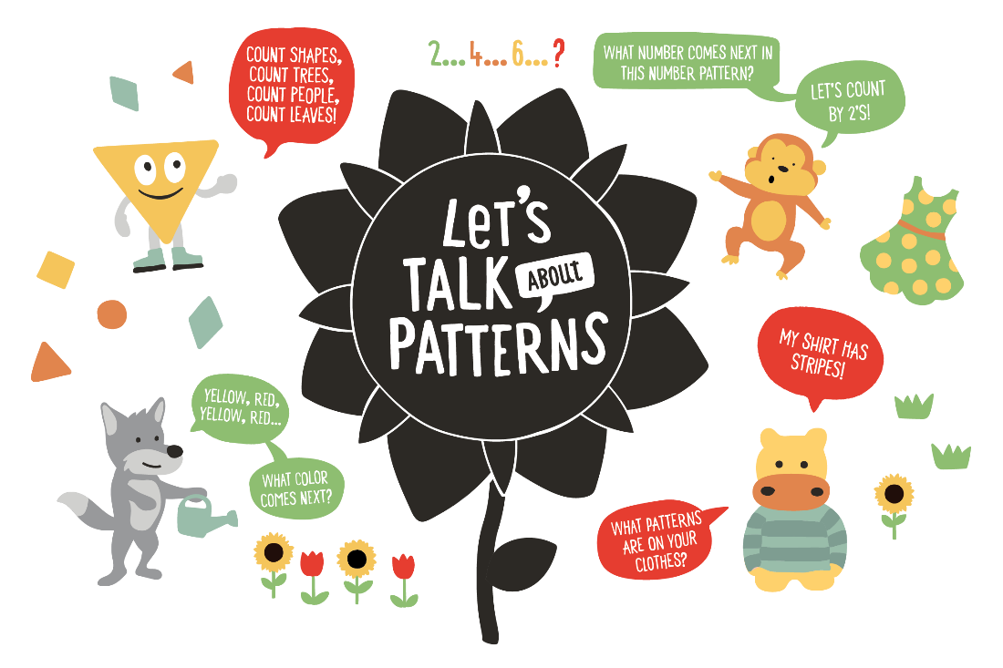

Facebook
Patterns are everywhere! From the design on blankets to the pattern of the sun going down and the moon rising, you and your little one can have fun looking for patterns around your community. For ideas on how to play with patterns, check out this tip sheet from @2SmallToFail: https://bit.ly/3mLZGEF

Did you know that thinking about patterns can help your child make sense of math? Understanding patterns helps little ones predict what happens next. Learn more about the simple and fun ways you can support your child’s early math development with these resources from @2SmallToFail: https://bit.ly/2G60aop

Twitter
Helping your child build early math skills is fun and simple! Talk together about numbers, count out loud, look for patterns, and use math words as you go about your day! #TalkingisTeaching

With your child, look for patterns in your community! Point to the traffic light as it changes and ask questions like, “What color is the light now?” and “What color will come next?” Find more tips on how to have fun with patterns here: https://bit.ly/3mLZGEF

When your child counts, he is building important math skills that will help him in kindergarten and beyond. Encourage your child to count by 2’s, 3’s, and 5’s! “Let’s count by 2! 2...4...6...what number comes next?” #TalkingisTeaching

Instagram
A pattern is something that repeats more than once, like yellow, red, yellow, red. Playing a pattern hunt is a fun way to spend time with your child and grow her early math skills! “I see stripes on your shirt! What other patterns can we find?” #TalkingisTeaching

Help your child look for patterns while folding laundry! Make a pattern with socks. Line them up like this: big sock, small sock, big sock, small sock. Ask your child to continue the pattern, and the find the matching pairs of socks! #TalkingisTeaching

