Let’s Talk About Spring!
Sample Social Media Posts
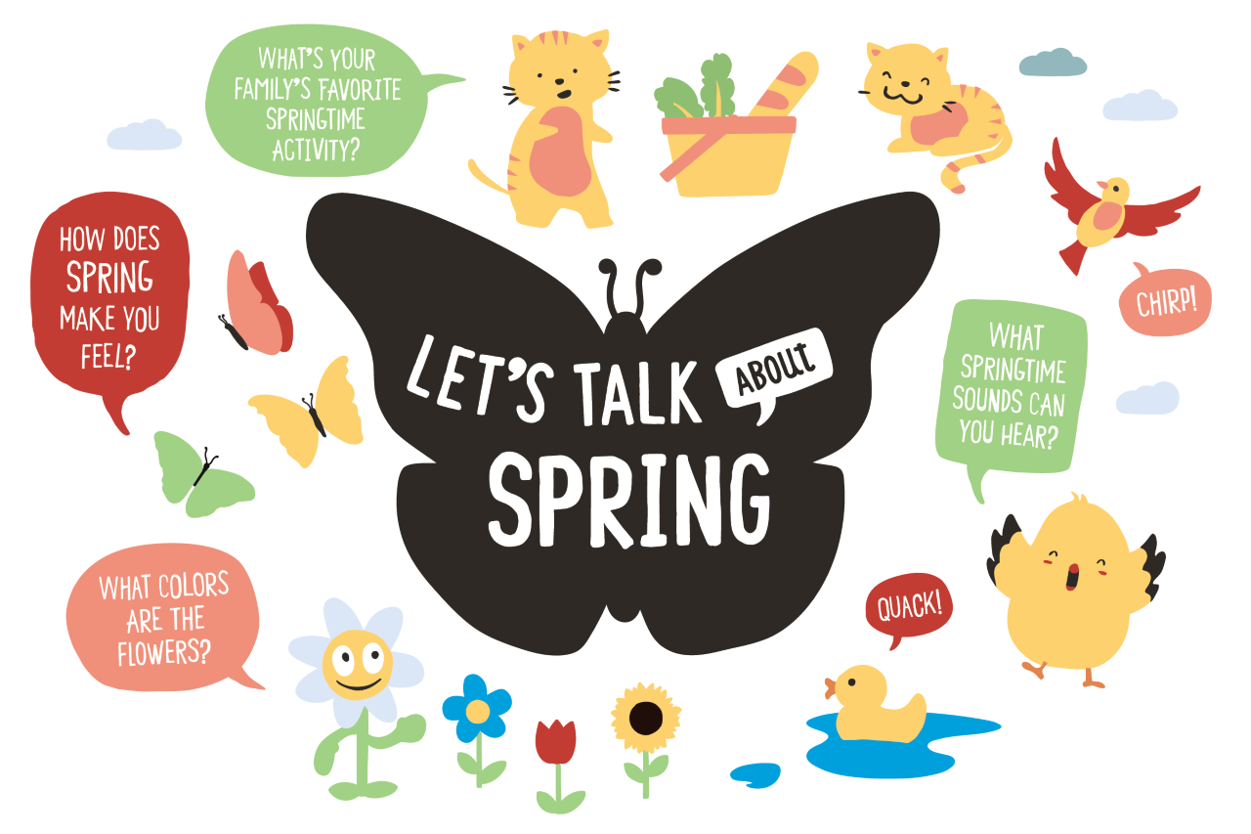
Facebook
With spring comes grass, blooming flowers, and warm sunshine! With your little one, find and name the colors all around you! “Can you find something pink? You’re right, the flower petals are pink!” #TalkingIsTeaching

In springtime, the weather can change from rainy one day to sunny the next! There are many ways that you and your little one can have fun with the weather in spring. Talk about how warm or cold it is or guess what the weather will be like tomorrow! #TalkingIsTeaching

Decorate your home with colorful springtime butterflies! With your child, drop food coloring onto a coffee filter and watch as the colors blend together! Then, pinch the middle of the coffee filter and wrap it with string or a pipe cleaner to make a homemade butterfly! Check out more springtime activity ideas from our partners at Scholastic: https://bit.ly/2QIQoxK

Twitter
It’s springtime, which means warmer weather, birds chirping, and more! With your child, talk about your favorite part of spring! “I like spring because the flowers start blooming! What do you like about spring?” #TalkingIsTeaching

Take some time this spring to relax with your little one. On a warm day, talk about the shapes and pictures you see in the clouds! “I see a teddy bear! What do you see in the clouds?” This calming activity will also help build your child’s communication skills. #TalkingIsTeaching

Math is all around us! From the number of petals on each flower to the patterns of the lines on a leaf, you and your child can have fun counting, finding patterns, and playing with math while out and about! #TalkingIsTeaching

Instagram
There are so many yummy and healthy fruits and vegetables to try in the spring! During snack time, talk about the fruits and vegetables with your little one. “What shape is the orange? What color is the apple?” #TalkingIsTeaching

